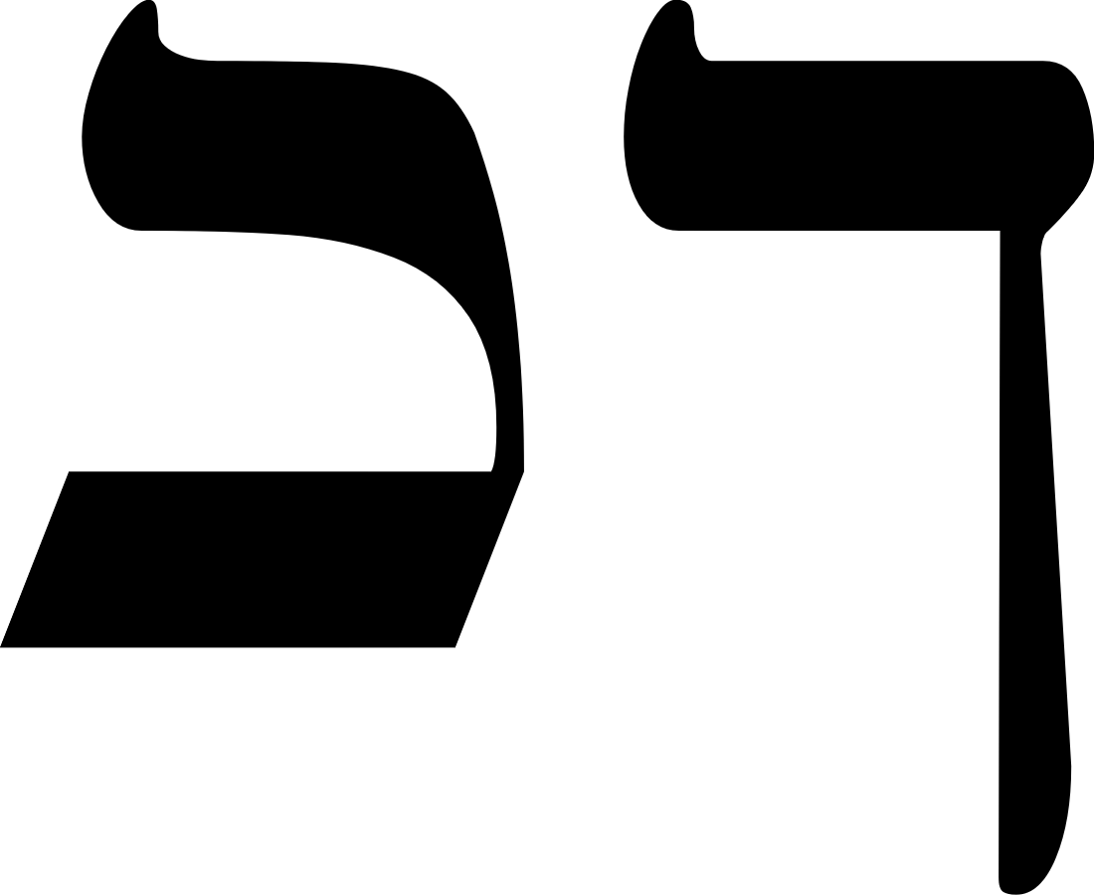 | 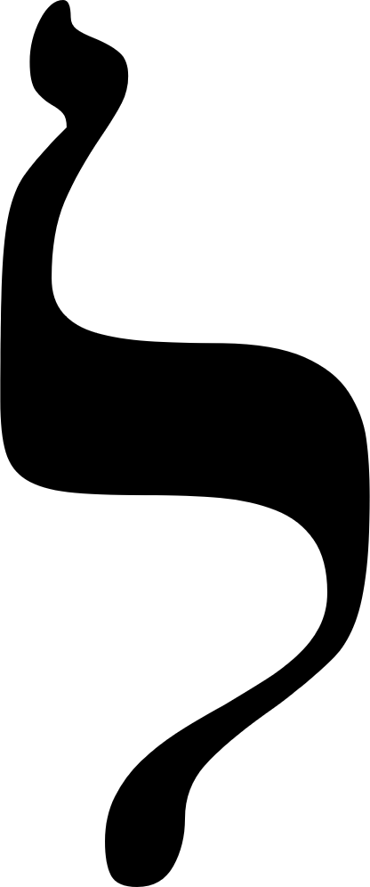 | 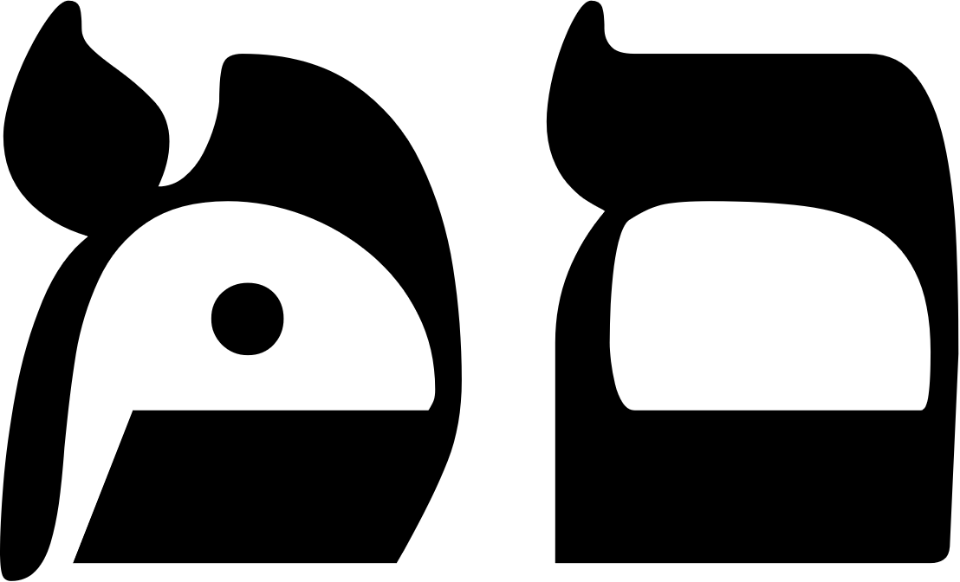 | 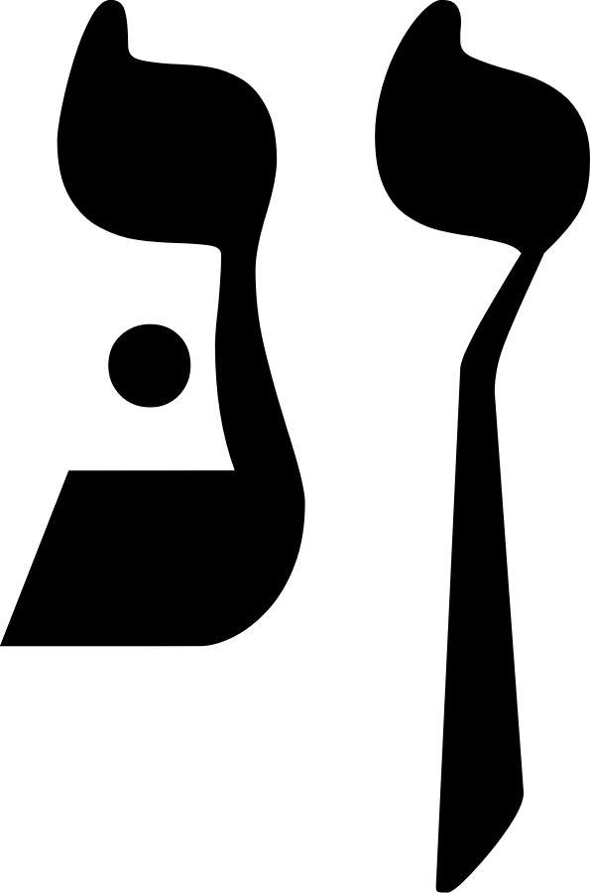 | 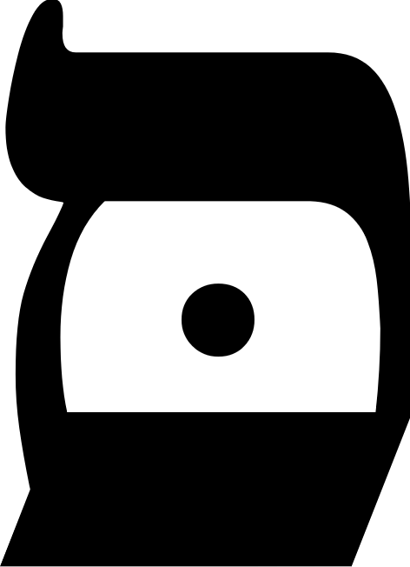
KAPH  20, 500 | Lamed  30 | Mem  40, 600 | Nun  50, 700 | samekh  60
Sound  K, kh  Palm of Hand  Wheel of Fortune  Jupiter  A wheel of six shafts, whereon revolve the Triad of Hermanubis, Sphinx, and Typhon | Sound  B  Ox-goad  Justice  Libra  A conventional figure of Justice with scales and balances | Sound  M  Water  The Hanged Man  Water  The figure of a hanged or crucified man | Sound  N  Fish  Death  Scorpio  A skeleton with a scythe mowing men. The scythe handle is a Tau | Sound  S  Prop, Support  Art, Temperance  Sagittarius  The figure of Diana huntress
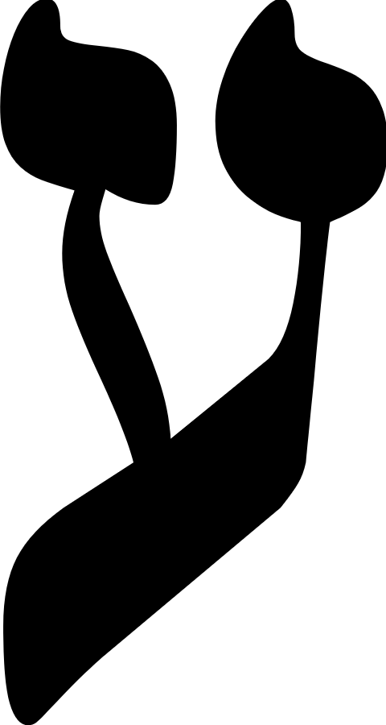 | 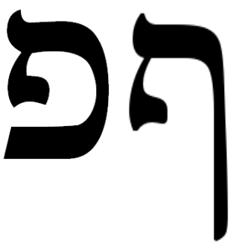 | 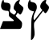
AYIN  70 | pe  80 800 | tzaddi  90, 900 | QOPH  100 | RESH  200
Sound  O, aa, ng(gutt)  Eye  The Devil  Capricorn  The figure of Pan or Priapus | Sound  P, ph  Mouth  The Tower  Mars  A tower struck by forked lightning | Sound  ts, tz, j.  Fish hook  The Emperor  Aries  A flame-clad god bearing equivalent symbols | Sound  q, qh (guttur.).  Back of Head  The Moon  Pisces  The waning moon | Sound  R  Head  The Sun  Sol  The Sun

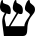 | 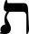
SHIN  300 | Tau  400 | Mem  40, 600 | Nun  50, 700 | samekh  60
Sound  Sh, s  Tooth  Judgement  Fire  Israfel blowing the Last Trumpet. The dead arising from their tombs | Sound  B  Sign of the Cross  The Universe  Saturn  Should contain a demonstration of the Quadrature of the Circle | Sound  M  Water  The Hanged Man  Water  The figure of a hanged or crucified man | Sound  N  Fish  Death  Scorpio  A skeleton with a scythe mowing men. The scythe handle is a Tau | Sound  S  Prop, Support  Art, Temperance  Sagittarius  The figure of Diana huntress
AYIN  70 | pe  80 800 | tzaddi  90, 900 | QOPH  100 | RESH  200
Sound  O, aa, ng(gutt)  Eye  The Devil  Capricorn  The figure of Pan or Priapus | Sound  P, ph  Mouth  The Tower  Mars  A tower struck by forked lightning | Sound  ts, tz, j.  Fish hook  The Emperor  Aries  A flame-clad god bearing equivalent symbols | Sound  q, qh (guttur.).  Back of Head  The Moon  Pisces  The waning moon | Sound  R  Head  The Sun  Sol  The Sun

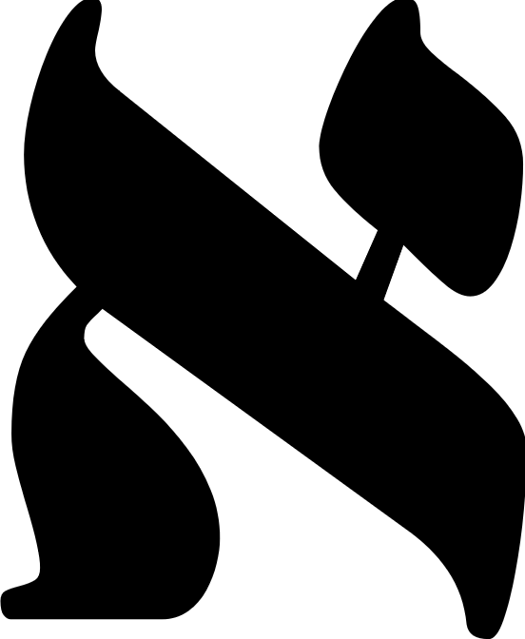 | 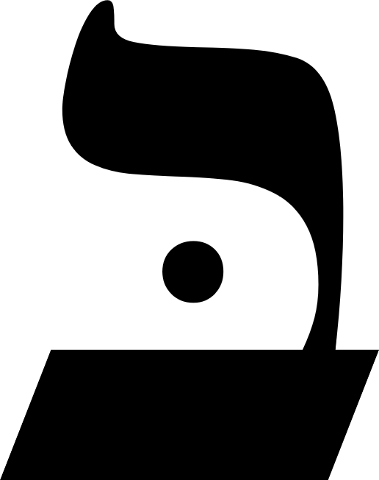 | 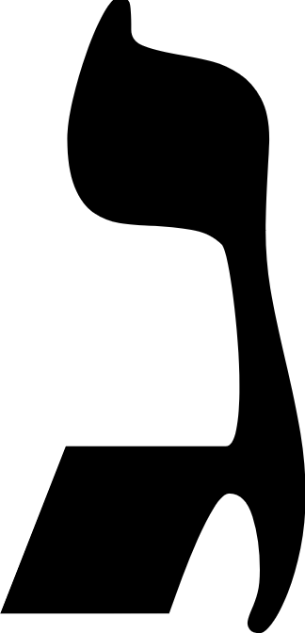 |  | 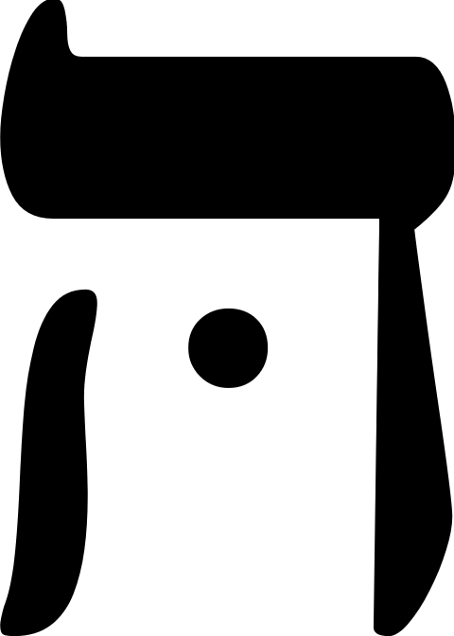
Aleph  1 | BETH  2 | gimel  3 | Daleth  4 | Heh  5
Sound  a (soft breathing).  Ox  The Fool  Air  A Bearded Ancient Seen in Profile | Sound  B  House  The Magician  Mercury  A fair youth with winged helmet and heels, equipped as a Magician, displays his art | Sound  G (hard)d, gh  Camel  The High Priestess  Luna  A crowned priestess sits before the veil of Isis between the Pillars of Seth | Sound  d, dh (flat th)  Door  The Empress  Venus  EmailCrowned with stars, a winged goddess stands upon the moon | Sound  h (rough breathing)  Window  The Star  Aquarius  The figure of a water-nymph disporting herself
 | 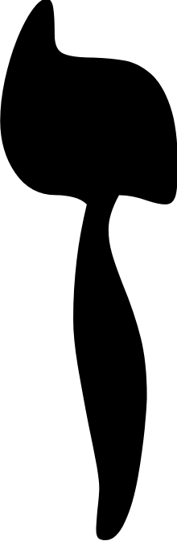 |  | 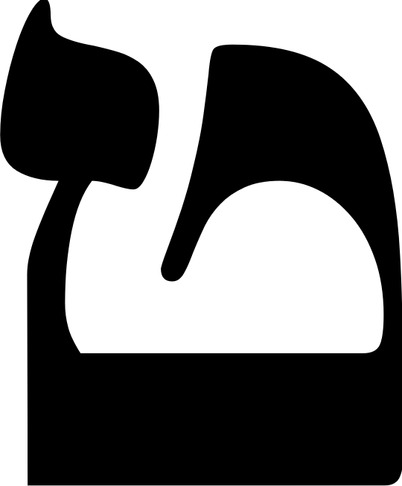
Vau  6 | Zayin  7 | CHETh  8 | Teth  9 | Yod  10
Sound  V,u,o  Nail, Peg  The Hierophant  Taurus  Between the Pillars sits an Ancient | Sound  Z, dz  Sword, Weapon  The Lovers  Gemini  A prophet, young, and in the Sign of Osiris Risen | Sound  ch (guttural).  Fence, Enclosure  The Chariot  Cancer  A young and holy king under the starry canopy | Sound  T  Serpent  Strength  Leo  A smiling woman holds the open jaws of a fierce and powerful lion | Sound  i, y (as in yes)  Hand  The Hermit  Virgo  Wrapped in a cloak and cowl, an Ancient walketh, bearing a lamp and staff

